Task № 1
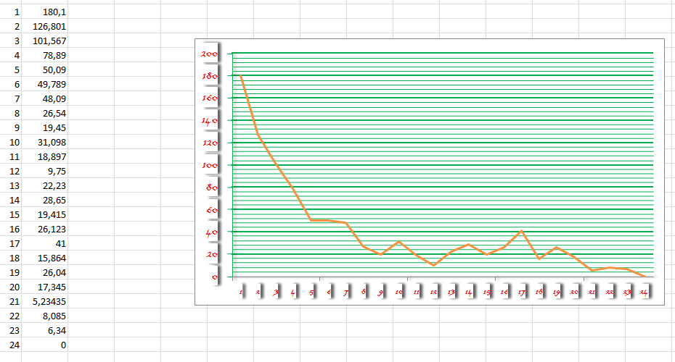
Number of population
Fitness

Task №2
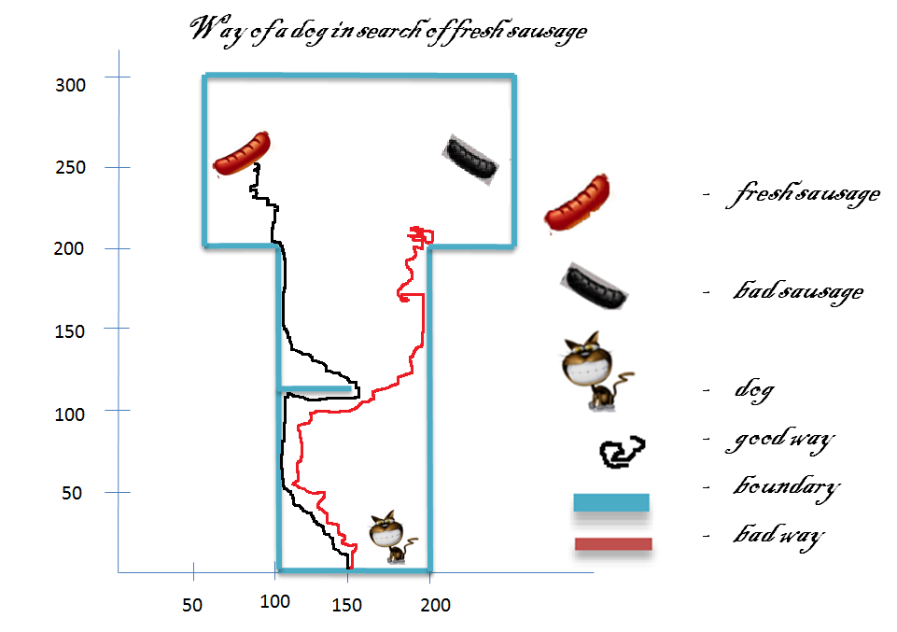
Weights:
0.8 -0.47 0.24 0.43 -0.15
-0.61 -0.14 -0.6 -0.68 -0.73
0.26 -0.68 0.13 -0.89 -0.59
0.55 0.49 -0.35 -0.67 -0.79
0.70 0.46 -0.55 0.81

