MAP:

1. first and second dog—bad dogs

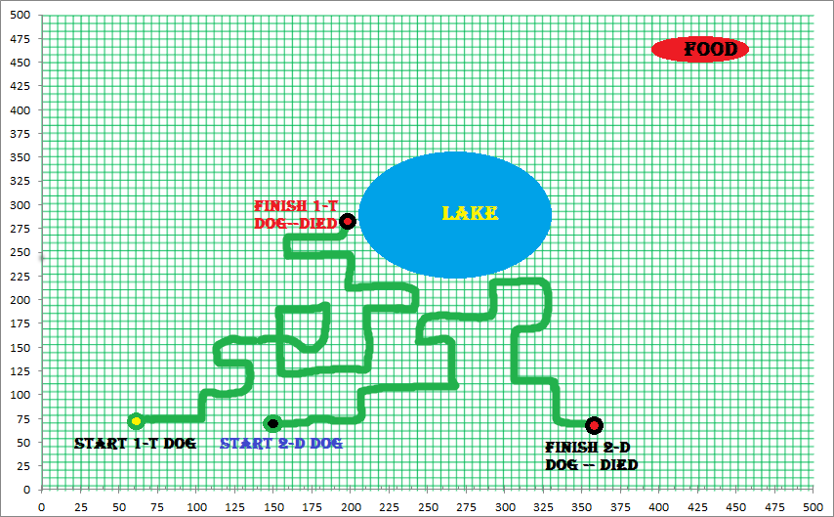

2. third and fourth dog—mediate dogs

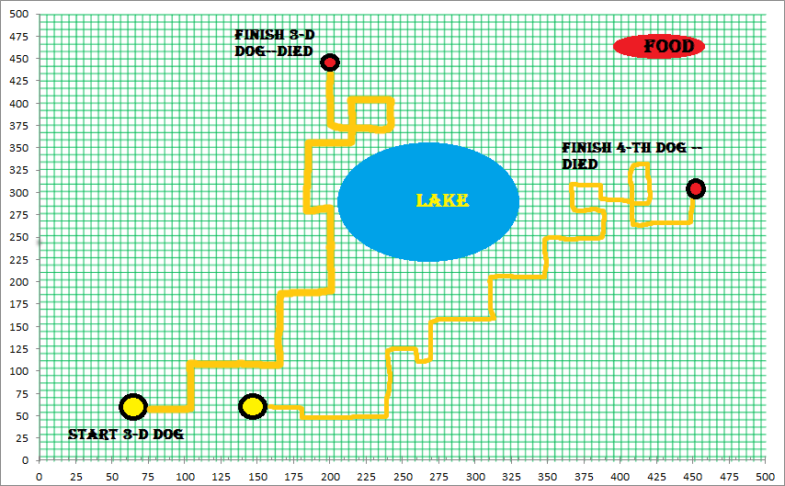

3. fifth dog --- clever a dog

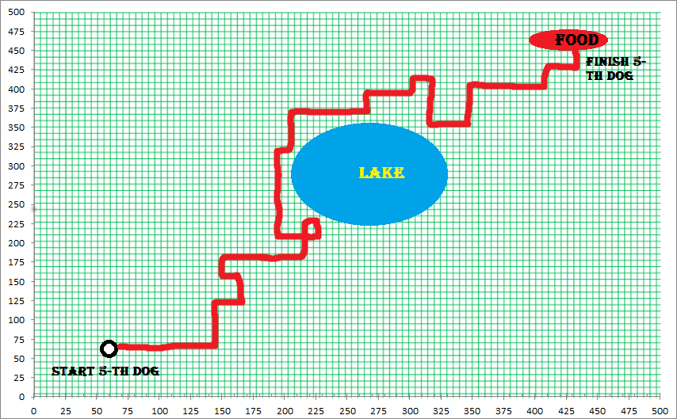

4. road dogs to food

1 dog |  | 2 dog |  | 3 dog |  | 4 dog |  | 5 dog
x | y | x | y | x | y | x | y | x | y
60 | 70 | 150 | 70 | 60 | 60 | 145 | 60 | 65 | 65
110 | 75 | 175 | 70 | 110 | 60 | 180 | 60 | 145 | 60
110 | 80 | 210 | 72 | 110 | 110 | 180 | 55 | 145 | 125
110 | 100 | 210 | 100 | 165 | 110 | 240 | 55 | 170 | 125
115 | 100 | 245 | 100 | 165 | 180 | 240 | 125 | 170 | 150
120 | 100 | 155 | 245 | 210 | 180 | 260 | 125 | 155 | 150
125 | 103 | 245 | 174 | 210 | 275 | 260 | 100 | 155 | 180
130 | 105 | 290 | 174 | 180 | 275 | 270 | 100 | 220 | 180
130 | 125 | 290 | 210 | 180 | 355 | 270 | 155 | 220 | 225
115 | 125 | 330 | 210 | 215 | 355 | 320 | 155 | 230 | 225
115 | 150 | 330 | 175 | 215 | 405 | 320 | 200 | 230 | 200
115 | 155 | 310 | 175 | 230 | 405 | 350 | 200 | 200 | 200
125 | 155 | 310 | 100 | 230 | 370 | 350 | 240 | 200 | 324
130 | 155 | 330 | 100 | 200 | 370 | 380 | 240 | 210 | 324
155 | 155 | 330 | 75 | 200 | 450 | 370 | 240 | 210 | 375
160 | 150 | 360 | 73 |  |  | 370 | 305 | 265 | 375
175 | 150 |  |  |  |  | 380 | 305 | 265 | 400
180 | 150 |  |  |  |  | 415 | 285 | 310 | 400
180 | 180 |  |  |  |  | 415 | 330 | 310 | 405
160 | 190 |  |  |  |  | 410 | 330 | 315 | 405
160 | 125 |  |  |  |  | 410 | 270 | 315 | 355
210 | 125 |  |  |  |  | 450 | 270 | 355 | 355
210 | 190 |  |  |  |  | 458 | 305 | 355 | 400
235 | 190 |  |  |  |  |  |  | 410 | 355
235 | 205 |  |  |  |  |  |  | 410 | 425
210 | 205 |  |  |  |  |  |  | 440 | 425
210 | 245 |  |  |  |  |  |  | 440 | 460
160 | 250
160 | 260
190 | 260
200 | 275

5. distance dogs to food

1 dog | 2 dog | 3 dog | 4 dog | 5 dog
537,5872 | 480,1042 | 544,8853 | 491,1466 | 537,8197
500,6246 | 465,9667 | 512,2499 | 471,6991 | 491,1466
496,7897 | 446,0314 | 474,2362 | 475,9464 | 439,8295
481,6638 | 421,9005 | 439,0046 | 447,3533 | 424,0578
478,3566 | 404,753 | 385,5191 | 385,1298 | 404,5986
475,0789 | 349,0702 | 356,0899 | 375,6661 | 414,3972
469,5466 | 340,6186 | 287,4456 | 398,1206 | 392,4602
464,7849 | 318,4274 | 311,0064 | 393,9543 | 350
449,6943 | 286,531 | 271,1549 | 344,4198 | 315,1587
459,8369 | 269,2582 | 239,2697 | 324,2299 | 308,5855
441,9559 | 302,0348 | 221,9234 | 282,3119 | 328,0244
438,4632 | 309,2329 | 207,4247 | 272,0294 | 347,1311
431,3351 | 379,4733 | 219,3171 | 234,094 | 267,2003
427,8142 | 373,6308 | 246,9818 | 225,6103 | 258,6426
410,6702 | 397,7751 | 230,2173 | 228,0351 | 235,8495
411,0961 | 393,2798 |  | 166,2077 | 185,6071
401,4038 |  |  | 162,865 | 175,5705
398,2462 |  |  | 175,6417 | 134,1641
375,3665 |  |  | 130,8625 | 132,0038
381,8377 |  |  | 131,5295 | 127,4755
430,2615 |  |  | 191,0497 | 155,7241
400,7805 |  |  | 191,0497 | 129,0349
348,2815 |  |  | 157,5087 | 96,04686
333,054 |  |  |  | 106,8878
321,014 |  |  |  | 40,31129
336,7863 |  |  |  | 36,40055
307,6118 |  |  |  | 10
342,0526
336,006
312,41
295,1694

6. Graphic road dogs to food

6.1. first and second dog

6.2. third and fourth dog

6.3. fifth dog --- clever dog

6.4 total

on the X-axis – distance(fitness)
on the Y axis - iteration

