Contemporary Data Processing Technology (CCOD)
Lab 1 (September 09, 2016)
Shurpo Dmitry, AS-36
Controll two metro cars using Speed, Distance, and Brake
In this practice we made a model of 2 trains on plain loop with length of 1000 points. Every train at the beginning have the speed of 10 points and move in clockwise stream.
On each iteration we change speed adding -1, 0, +1 at random. Speed should be >= 0 and <20.
When the distance between trains is 0 we stop the movement.
The program can be run in every browser(it’s an .html page) Here is the source code:

Style.css
body {
background:url(../img/3.jpg);
background-size: cover;
color: white
}

.subway_loop {
margin: 10% auto;
width: 159px;
height: 159px;
border: 1px solid white;
border-radius: 80px;
}

.train {
position: relative;
border: 1px solid;
}

.firsttrain {
left: 50%;
top: 0;
border-color: red;
}

.secondtrain {
left: 50%;
top: 100%;
border-color: gray;
}

.speed {
position: fixed;
font-size: 14px;
left: 5%;;
}

.firsttrainSpeed {
bottom: 0px;
}

.secondtrainSpeed {
bottom: 20px;
}

.distance{
position: fixed;
font-size: 14px;
left: 65%;
}
.firsttrainDistance {
bottom: 0px;
}

.secondtrainDistance {
bottom: 20px;
}

Script.js
var secondtrain = document.querySelector(".secondtrain");
var firsttrain = document.querySelector(".firsttrain");
var firsttrainSpeedValue = document.querySelector(".firsttrainSpeedValue");
var firsttrainDistanceValue = document.querySelector(".firsttrainDistanceValue");
var secondtrainSpeedValue = document.querySelector(".secondtrainSpeedValue");
var secondtrainDistanceValue = document.querySelector(".secondtrainDistanceValue");
var startSpeed = 0.001;
var x0 = 77;
var y0 = 74;
var r = 79;
var i = -1.5;
var j = 1.5;
var start = Date.now();
var firstSpeed = 0.001,
secondSpeed = 0.001;
var rand;
var firstway = 0,
secondway = 0;

var rightFirst = firsttrain.style.left + 20;
var leftFirst = firsttrain.style.left;

var rightSecond = secondtrain.style.left + 20;
var leftSecond = secondtrain.style.left;

var topFirst = firsttrain.style.top;
var bottomFirst = firsttrain.style.top - 10;

var topSecond = secondtrain.style.top - 10;
var bottomSecond = secondtrain.style.top;

var timer = setInterval(function () {
var timePassed = Date.now() - start;
firsttrain.style.left = x0 + r * Math.cos(i) - 35 + 'px';
firsttrain.style.top = y0 + r * Math.sin(i) - 5 + 'px';

secondtrain.style.left = x0 + r * Math.cos(j) - 10 + 'px';
secondtrain.style.top = y0 + r * Math.sin(j) - 5 + 'px';

i = i + firstSpeed;
j = j + secondSpeed;

rand = randomValue(-1, 1) / 10000;
if (firstSpeed > 0 || rand > 0) {
firstSpeed += rand;
}
if (firstSpeed > 0.002) firstSpeed = 0.002;
firstway += firstSpeed;

firsttrainSpeedValue.innerHTML = Math.round(firstSpeed * 10000);

firsttrainDistanceValue.innerHTML =500 + Math.round(Math.abs(firstway - secondway) / 6.0414 * 1000);

rand = randomValue(-1, 1) / 10000;
if (secondSpeed > 0 || rand > 0) {
secondSpeed += rand;
}
if (secondSpeed > 0.002) secondSpeed = 0.002;
secondway += secondSpeed;

secondtrainSpeedValue.innerHTML = Math.round(secondSpeed * 10000);

secondtrainDistanceValue.innerHTML = 1000 - (500 + Math.round(Math.abs(firstway - secondway) / 6.0414 * 1000));

if (Math.abs(firstway - secondway) > 3.02) {
clearInterval(timer);
}

}, 2);

function randomValue(min, max) {
return Math.round(min - 0.5 + Math.random() * (max - min + 1));
}

Index.html
<!DOCTYPE html>
<html lang="en">
<head>
<meta charset="UTF-8">
<title></title>
<link rel="stylesheet" href="css/style.css">
</head>
<body>
<div class="subway_loop">
<img class="train secondtrain" src="img/1.png" width="20px" height="10px">
<img class="train firsttrain" src="img/2.png" width="20px" height="10px">
</div>

<div class="speed firsttrainSpeed">first speed: <span class="firsttrainSpeedValue"></span></div>
<div class="speed secondtrainSpeed">second speed: <span class="secondtrainSpeedValue"></span></div>

<div class="distance firsttrainDistance">first to second distance: <span class="firsttrainDistanceValue"></span></div>
<div class="distance secondtrainDistance">second to first distance: <span class="secondtrainDistanceValue"></span></div>

<script src="js/script.js"></script>
</body>
</html>

Results:
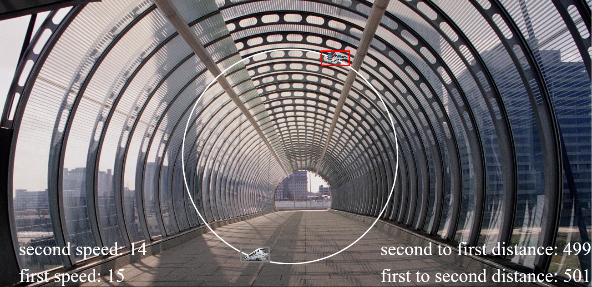
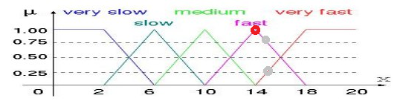
RED: GRAY:
Very slow: 0 Very slow: 0
Slow: 0 Slow: 0
Medium: 0 Medium: 0
Fast: 1 Fast: 0.75
Very fast: 0 Very fast: 0.25
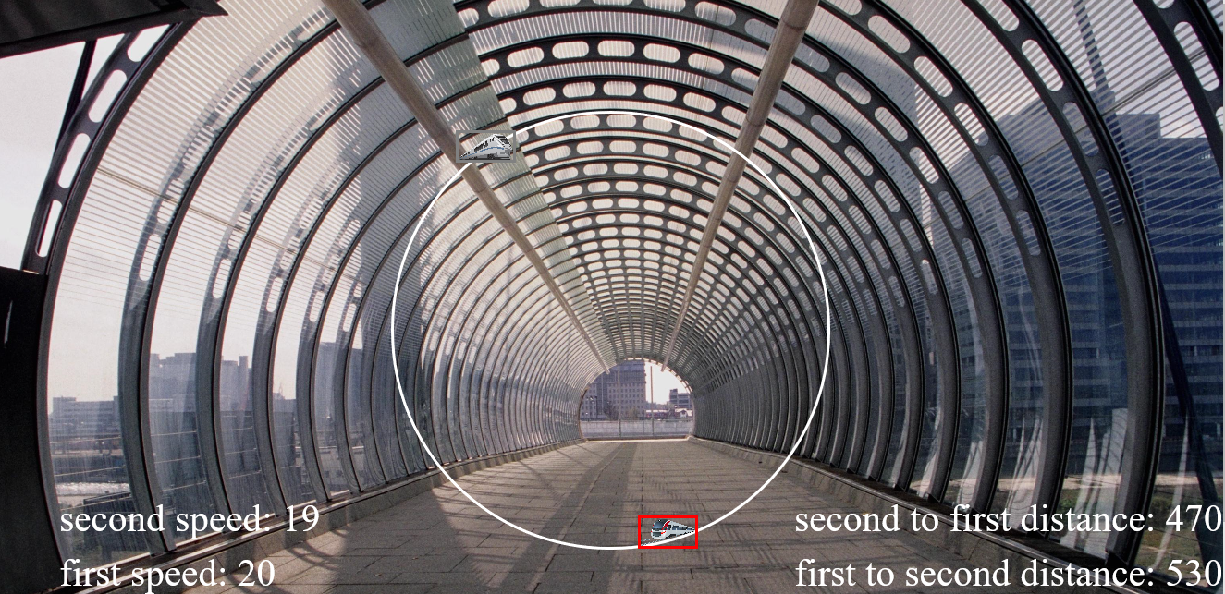
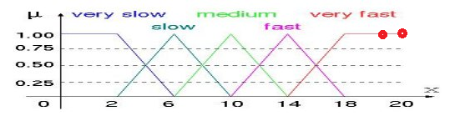
RED: GRAY:
Very slow: 0 Very slow: 0
Slow: 0 Slow: 0
Medium: 0 Medium: 0
Fast: 0 Fast: 0
Very fast: 1 Very fast: 1
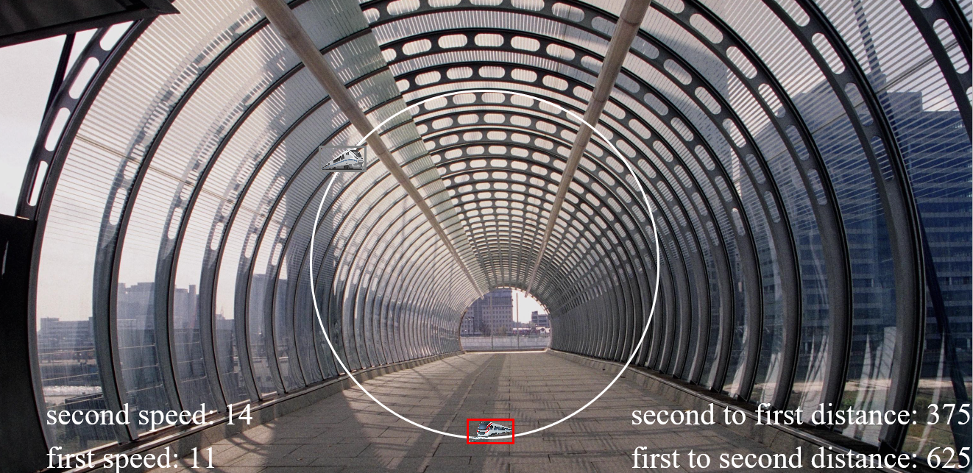
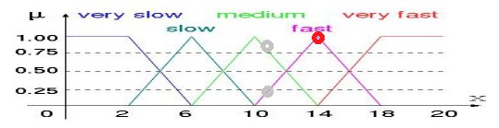
RED: GRAY:
Very slow: 0 Very slow: 0
Slow: 0 Slow: 0
Medium: 0 Medium: 0.75
Fast: 1 Fast: 0.25
Very fast: 0 Very fast: 0
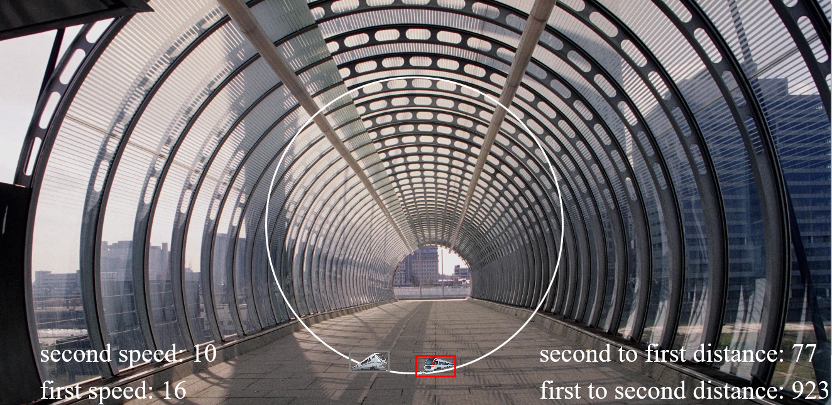
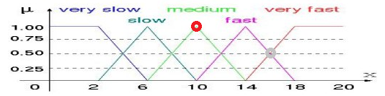
RED: GRAY:
Very slow: 0 Very slow: 0
Slow: 0 Slow: 0
Medium: 1 Medium: 0
Fast: 0 Fast: 0.5
Very fast: 0 Very fast: 0.5

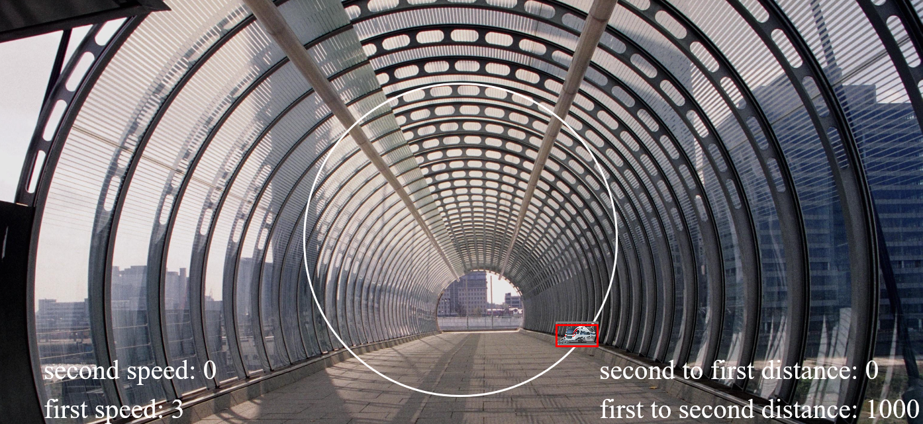
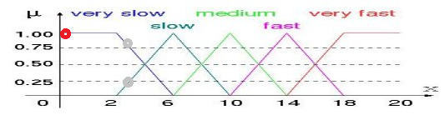
RED: GRAY:
Very slow: 1 Very slow: 0.75
Slow: 0 Slow: 0.25
Medium: 0 Medium: 0
Fast: 0 Fast: 0
Very fast: 0 Very fast: 0

