MINISTRY OF EDUCATION REPUBLIC OF ESTABLISHMENT OF EDUCATION "BREST STATE TECHNICHNICAL UNIVERSITY"

Practice work №1
«Evolutionary Computation»
Subject: «All One Problem»

Made by:
Vladislav Shukalo
Checked by:
Pr. Imada
2016

Task
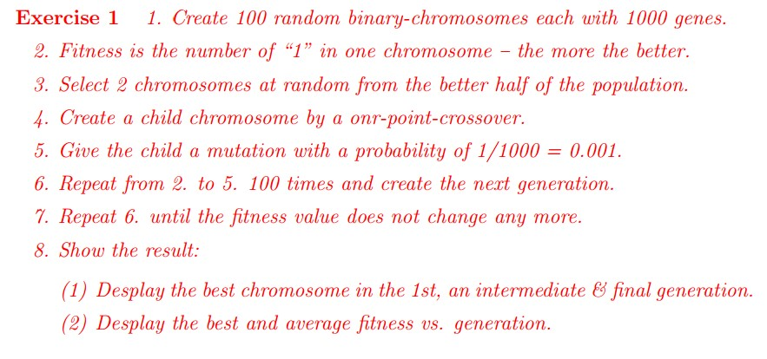

Code(C++):
#include <iostream>
#include <string>
#include <Windows.h>
#include <vector>

using namespace std;

int main()
{
vector<int> bc; //vector1 - best chromosom
vector<int> af; //vector2 - average fitness

int ch[100][1000]; //massive of chromosom
int child[100][1000]; //massive of children
int a[100]; //massive fitness of chromosom
int fi[20][3];
int n = 0, v = 0;
int x1, x2, d, g=1;
for (int i = 0; i < 5; i++)
{
for (int f = 0; f < 3; f++)
{
fi[i][f] = 0;
}
}
for (int i = 0; i < 100; i++) //input 1-st generation
{
for (int f = 0; f < 1000; f++)
{
ch[i][f] = rand() % 2;
}
}
for (int i = 0; i < 100; i++) //calculate fitness of each chromosom
{
a[i] = 0;
for (int f = 0; f < 1000; f++)
{
if (ch[i][f] == 1) { a[i] = a[i] + 1; }
}
}

for (int i = 0; i < 100; i++) //sorting 1-st generation and fitness values
{
for (int j = 100 - 1; j > i; j--)
{
if (a[j] > a[j - 1])
{
swap(a[j], a[j - 1]);
swap(ch[j], ch[j - 1]);
}
}
}
bc.push_back(a[1]); //calculating best and average fitness of generation
int y1 = 0;
for (int i = 0; i < 100; i++)
{
y1 = y1 + a[i];
}
af.push_back(y1/100);
cout << bc[0] << ' ';
for (int end = 0; end==0;)
{
//---------------------------------------------------------------
for (int s = 0; s < 100; s++) //making next generation of chromosom
{
x1 = rand() % 50;
x2 = rand() % 50;
d = rand() % 1000;
for (int i = 0; i < d; i++)
{
child[s][i] = ch[x1][i];
}
for (int i = d; i > d && i < 1000; i++)
{
child[s][i] = ch[x2][i];
}
s = s + 1;
for (int i = 0; i < d; i++)
{
child[s][i] = ch[x2][i];
}
for (int i = d; i > d && i < 1000; i++)
{
child[s][i] = ch[x1][i];
}
}

for (int i = 0; i < 100; i++) //mutation 1
{
for (int f = 0; f < 1000; f++)
{
int mut = rand() % 1000;
if (mut = 0) {
if (child[i][f] == 0) child[i][f] = 1;
if (child[i][f] == 1) child[i][f] = 0;
}
}
}
for (int i = 0; i < 100; i++)
{
a[i] = 0;
for (int f = 0; f < 1000; f++)
{
if (child[i][f] == 1) { a[i] = a[i] + 1; }
}
}

for (int i = 0; i < 100; i++) //sorting 1
{
for (int j = 100 - 1; j > i; j--)
{
if (a[j] > a[j - 1])
{
swap(a[j], a[j - 1]);
swap(child[j], child[j - 1]);

}
}
}
bc.push_back(a[1]); //calculating best and average fitness of generation
int y2 = 0;
for (int i = 0; i < 100; i++)
{
y2 = y2 + a[i];
}
af.push_back(y2 / 100);
cout << bc[g] << ' ';
if (g > 1)
{
if (bc[g] == bc[g - 1] || bc[g] == bc[g - 2])
{
v = v + 1;
}
else v = 0;
}
if (bc[g] == 1000 || v == 100) end = 1;
g++;

for (int s = 0; s < 100; s++) //making next generation of chromosom 2
{
x1 = rand() % 50;
x2 = rand() % 50;
d = rand() % 1000;
for (int i = 0; i < d; i++)
{
ch[s][i] = child[x1][i];
}
for (int i = d; i > d && i < 1000; i++)
{
ch[s][i] = child[x2][i];
}
s = s + 1;
for (int i = 0; i < d; i++)
{
ch[s][i] = child[x2][i];
}
for (int i = d; i > d && i < 1000; i++)
{
ch[s][i] = child[x1][i];
}
}

for (int i = 0; i < 100; i++) //mutation 2
{
for (int f = 0; f < 1000; f++)
{
int mut = rand() % 1000;
if (mut = 0) {
if (ch[i][f] == 0) ch[i][f] = 1;
if (ch[i][f] == 1) ch[i][f] = 0;
}
}
}
for (int i = 0; i < 100; i++)
{
a[i] = 0;
for (int f = 0; f < 1000; f++)
{
if (ch[i][f] == 1) { a[i] = a[i] + 1; }
}
}

for (int i = 0; i < 100; i++) //sorting 2
{
for (int j = 100 - 1; j > i; j--)
{
if (a[j] > a[j - 1])
{
swap(a[j], a[j - 1]);
swap(ch[j], ch[j - 1]);
}
}
}
bc.push_back(a[1]); //calculating best and average fitness of generation
int y3 = 0;
for (int i = 0; i < 100; i++)
{
y3 = y3 + a[i];
}
af.push_back(y3 / 100);
cout << bc[g] << ' ';
if (bc[g] == bc[g - 1] || bc[g] == bc[g - 2])
{
v = v + 1;
}
else v = 0;
if (bc[g] == 1000 || v == 100) end = 1;
g++;
}
cout << endl<<"-------------------------------------------------------------------------------------------";
cout <<endl<< "Best chromosom in 1-st generation:"<<bc[1];
cout << endl << "Best chromosom in intermediate generation:" <<bc[bc.size()/2];
cout << endl << "Best chromosom in final generation:" <<bc[bc.size()-1]<< endl<<endl;
cout << "Click ENTER to continue and display best and average fitness vs generation..."<< endl;
system("pause");
for (int i = 0; i < bc.size(); i++)
{
cout << "Generation " << i + 1 << ": " << "best:" << bc[i] << " average:" << af[i] << endl;
}

system("pause");
return 0;
}

Result
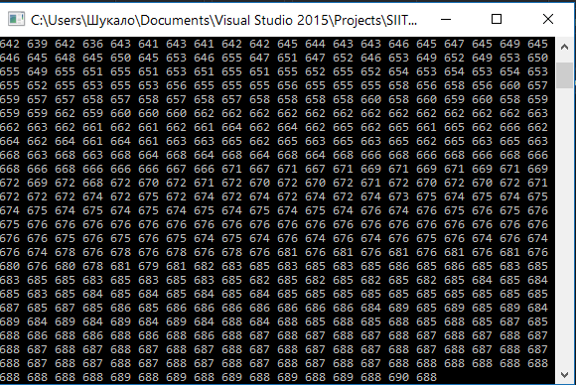
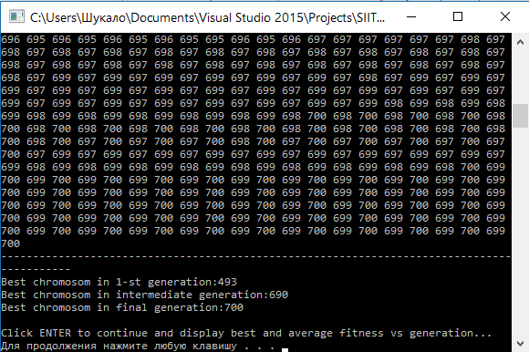
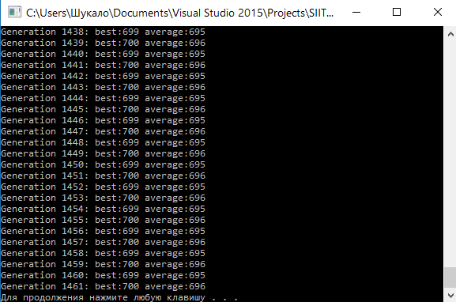
Describtion
I decided to perform a task in C ++. Workspace: visual studio 2015.

At first i Create 100 random binary-chromosomes each with 1000 genes. Then I defined fitness - is the number of “1” in one chromosome – the more the better. After that selected 2 chromosomes at random from the better half of the population and created a child chromosome by a onr-point-crossover. Then I gived the child a mutation with a probability of 1/1000 = 0.001 and repeated cycle 100 times and created the next generation. After that repeated until the fitness value does not change any more(100 reps).

