package com.badmanners;
import java.util.Random;
public class Main
{
static int INPUTS = 6;
static Random rand = new Random(System.currentTimeMillis());
static class Network
{
double[] values; // hidden layer
double[] weights;
double result;
public Network(double[] values, double[] weights)
{
if(values != null)
this.values = values;
else
this.values = new double[INPUTS];
if(weights != null)
this.weights = weights;
else
{
this.weights = new double[INPUTS * (INPUTS + 1)];
for(int i = 0; i < this.weights.length; i++)
this.weights[i] = rand.nextDouble() * 2 - 1;
}
}
int calculate(int[] inputData)
{
for(int i = 0; i < INPUTS; i++)
for(int j = 0; j < INPUTS; j++)
values[i] += inputData[j] * weights[INPUTS * i + j];
for(int i = 0; i < INPUTS; i++)
result += values[i] * weights[INPUTS * INPUTS + i];
if(result >= 0)
return 1;
else
return 0;
}
}
static class Generation
{
Network[] networks;
int[] fitness;
public Generation(Network[] networks)
{
if(networks != null)
this.networks = networks;
else
{
this.networks = new Network[100];
for(int i = 0; i < this.networks.length; i++)
this.networks[i] = new Network(null, null);
}
fitness = new int[this.networks.length];
}
int calculateSortAndGetBestFitness()
{
for(int i = 0; i < 100; i++)
for(int j=0; j<) //TODO
return fitness[0];
}
Generation getNewGeneration()
{
}
}
public static void main(String[] args)
{
System.out.println(new Network(null, null).calculate(new int[]{1, 1, 1, -1, 1, 1}));
}
}
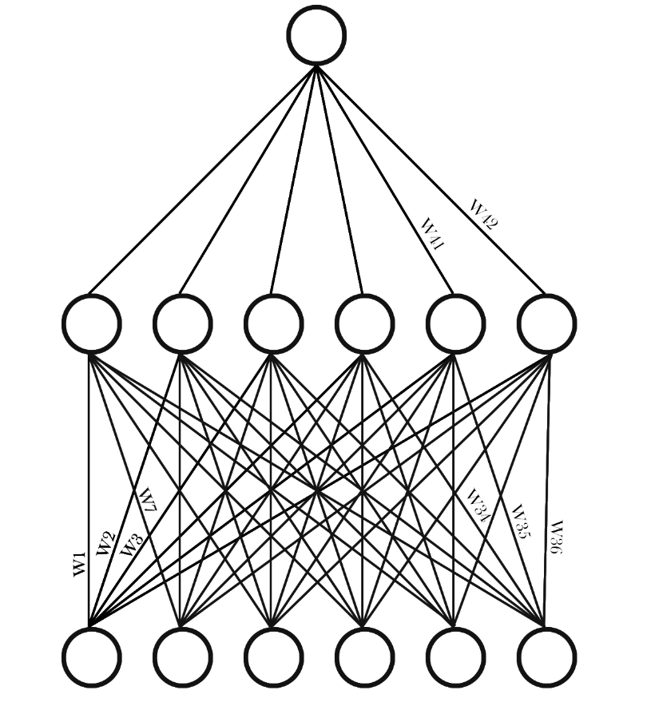
-1 | -1 | -1 | -1 | -1 | 1
-1 | -1 | -1 | -1 | 1 | -1
-1 | -1 | -1 | 1 | -1 | -1
-1 | -1 | -1 | 1 | 1 | 1
-1 | -1 | 1 | -1 | -1 | -1
-1 | -1 | 1 | -1 | 1 | 1
-1 | -1 | 1 | 1 | -1 | 1
-1 | -1 | 1 | 1 | 1 | -1
-1 | 1 | -1 | -1 | -1 | -1
-1 | 1 | -1 | -1 | 1 | 1
-1 | 1 | -1 | 1 | -1 | 1
-1 | 1 | -1 | 1 | 1 | -1
-1 | 1 | 1 | -1 | -1 | 1
-1 | 1 | 1 | -1 | 1 | -1
-1 | 1 | 1 | 1 | -1 | -1
-1 | 1 | 1 | 1 | 1 | 1
1 | -1 | -1 | -1 | -1 | -1
1 | -1 | -1 | -1 | 1 | 1
1 | -1 | -1 | 1 | -1 | 1
1 | -1 | -1 | 1 | 1 | -1
1 | -1 | 1 | -1 | -1 | 1
1 | -1 | 1 | -1 | 1 | -1
1 | -1 | 1 | 1 | -1 | -1
1 | -1 | 1 | 1 | 1 | 1
1 | 1 | -1 | -1 | -1 | 1
1 | 1 | -1 | -1 | 1 | -1
1 | 1 | -1 | 1 | -1 | -1
1 | 1 | -1 | 1 | 1 | 1
1 | 1 | 1 | -1 | -1 | -1
1 | 1 | 1 | -1 | 1 | 1
1 | 1 | 1 | 1 | -1 | 1
1 | 1 | 1 | 1 | 1 | -1

