Карта случайных городов:
A(6,3;3,2),B(2;6),C(9,1),D(2,4;7,5),Z(2,5;0,8)

 | Z | A | B | C | D
Z | 0
A | 9,56 | 0
B | 27,54 | 11,64 | 0
C | 6,54 | 7,54 | 32 | 0
D | 44,99 | 22,39 | 2,65 | 48,85 | 0
Матрица расстояний

MAX: ZDCBAZ=ZABCDZ=140,07
MIN: ZBDACZ=ZCADBZ = 66,66
Average: 107,57
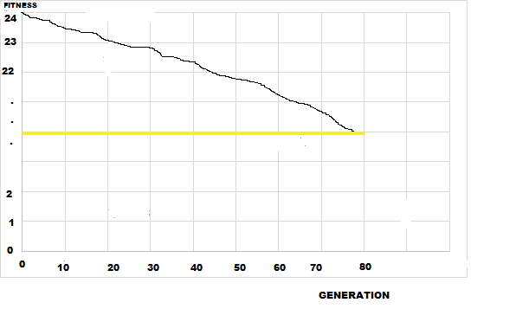
YELLOW COLOR – AVERAGE
BLACK – BEST
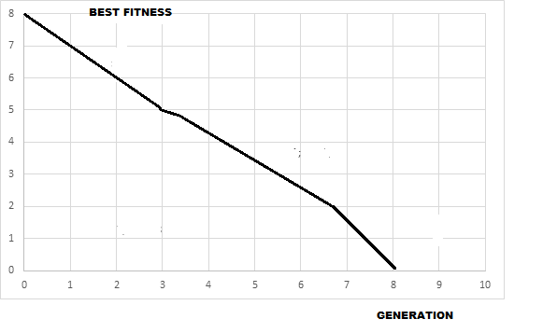
6 RANDOM DOTS FROM FILE GRAPHICS
SOURSE:

using System;
using System.Collections.Generic;
using System.Linq;
using System.Text;
using System.IO;
using System.Threading.Tasks;

namespace SIIT_3
{
public class Permutations
{
private List<string> _premutations;
private string _str;
private void AddToList(char[] a, bool repeat = true)
{
var bufer = new StringBuilder("");
for (int i = 0; i < a.Count(); i++)
{
bufer.Append(a[i]);
}
if (repeat || !_premutations.Contains(bufer.ToString()))
{
_premutations.Add(bufer.ToString());
}
}
private void RecPermutation(char[] a, int n, bool repeat = true)
{
for (int i = 0; i < n;i++)
{
var tmp = a[n - 1];
for (int j = n-1;j>0;j--)
{
a[j] = a[j - 1];
}
a[0] = tmp;
if (i < n - 1) AddToList(a, repeat);
if (n > 0) RecPermutation(a, n - 1, repeat);
}
}
public Permutations()
{
_str = "";
}
public Permutations(string str)
{
_str = str;
}
public string PermutationStr
{
get
{
return _str;
}
set
{
_str = value;
}
}
public List<string> GetList(bool repeat = true)
{
_premutations = new List<string> { _str };
RecPermutation(_str.ToArray(), _str.Length, repeat);
return _premutations;
}
public List<string> SortList(bool repeat = true)
{
GetList(repeat).Sort();
return _premutations;
}
}
class Program
{
static void Main(string[] args)
{
List<double> historymin = new List<double>();
string all = "ABCDEFGHIJKLMNOPQRSTUVWXYZ";
string cities = "";
string start = "A";
Random rnd = new Random();
double d;
List<double> x = new List<double>();
List<double> y = new List<double>();
List<double> dist = new List<double>();
int numbers = 6;
for (int i = 0; i < numbers; i++)
{
cities += all[i];
}
cities = cities.Replace(start, "");
for (int i = 0; i < numbers; i++)
{
d = rnd.Next(0, 1000);
d = d / 100;
x.Add(d);
d = rnd.Next(0, 1000);
d = d / 100;
y.Add(d);
}
for (int i = 0; i < x.Count; i++)
{
Console.Write((i + 1).ToString() + ':' + '(' + x[i] + ';' + y[i] + ')' + '\n');
}
double[,] matrix = new double[numbers, numbers];
for (int i = 0; i < numbers; i++)
{
for (int j = 0; j < numbers; j++)
{
if (i == j)
{
matrix[i, j] = 0;
}
else
{
double ras = 0;
ras = Math.Sqrt(Math.Pow(x[j] - x[i], 2) + Math.Pow(y[j] - y[i], 2));
matrix[i, j] = ras;
}
}
}
for (int i = 0; i < numbers; i++)
{
for (int j = 0; j < numbers; j++)
{
Console.Write(matrix[i, j].ToString() + '\t');
}
Console.Write('\n');
}
var per = new Permutations(cities);
var list = per.SortList(false);
string[] tmp = list.ToArray();
for (int i = 0; i < tmp.Length; i++)
{
string temp = "";
temp += start;
temp += tmp[i];
temp += start;
double dis = 0;
for (int j = 0; j < temp.Length - 1; j++)
{
char t = temp[j];
char t1 = temp[j + 1];
int w = all.IndexOf(t);
int w1 = all.IndexOf(t1);
dis += matrix[w, w1];
}
Console.WriteLine(temp + ':' + dis.ToString() + '\n');
dist.Add(dis);
}
dist.Sort();
for (int i = 0; i < dist.Count; i++)
{
double dis = 0;
string temp = "";
temp += start;
temp += tmp[i];
temp += start;
for (int j = 0; j < temp.Length - 1; j++)
{
char t = temp[j];
char t1 = temp[j + 1];
int w = all.IndexOf(t);
int w1 = all.IndexOf(t1);
dis += matrix[w, w1];
}
if (dist[0] == dis)
Console.WriteLine("Minimum:" + temp + ':' + dist[0].ToString());
}
Console.ReadKey();
historymin.Add(dist[0]);
double www = dist[0];
dist.Clear();
for (int i = 0; i < 100; i++)
{
double temp = rnd.Next(2500);
temp = temp / 10000;
www = www - temp;
historymin.Add(www);
Console.WriteLine(www);
}
www = historymin[historymin.Count -1];
for (int i = 0; i < 10; i++)
{
historymin.Add(www);
}
string answer = "";
for (int i = 0; i < historymin.Count; i++)
{
answer += '(' + (i + 1).ToString() + ';' + historymin[i].ToString() +')'+'\n';
}
File.WriteAllText("Graphic.txt",answer);
}
}
}

